**Year 8 – Humanities and Social Sciences**

Task 2 – History Inquiry: Medieval Societal Roles

Name: ______________________________________

Date Due: ___________________________________

|  |  |
| --- | --- |
| **Part A: Inquiry Process** | **Weighting (5%)** |
| Part A Total: | **/62** |
| **Part B:**  **Museum Display** | **Weighting (3%)** |
| Part B Total: | **/54** |
| Total: | **/116** |

**Part A: Inquiry Process – 70 Marks (Weighting**

You have been hired by the Museum of Natural History to and research create a museum display as part of the exhibit on different aspects of life in Medieval Europe (c. 590-1500). Your research will focus on the societal hierarchy and roles of the era. You have been provided with some guiding questions by the last curator at the museum but will need to devise three of your own in order to create the best museum display.

You will need to create focus questions, conduct research and record your findings about both the feudal system and your chosen societal role.

Part B: Museum Display - 54 marks (Weighting

Present your findings as a museum display. Your museum display will need an object and information to teach the visitors to the museum about your chosen societal role.

The museum display is to be focused on the daily life of your chosen societal role and should include information on:

* Rights and Privileges in society
* Daily Life i.e. Clothes, food, housing.
* Significance to Medieval Society
* Other Interesting Facts about them and/or your chosen object.

Part C: In-Class Validation (Weighting 2%)

Complete questions in an in-class inquiry that relate to the assessment, the feudal system and the significance, relationships and daily life of your chosen societal role.

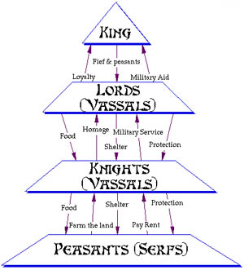

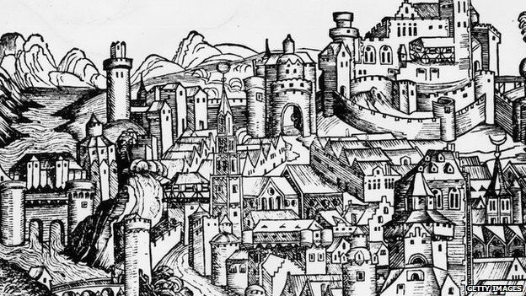

**Assignment Checklist**

* Devise three focus questions.
* Complete the inquiry booklet to record your information. You should use both class time and homework time out of school to complete this assessment.
* Create a museum display (model) to communicate your findings.

IMPORTANT: you must provide written information about your societal role with your museum display, the purpose of the display is to be informative and communicate your research findings.

* Submit a formal bibliography to prove to the museum and other historians that your research is reliable.
* Complete a self-reflection

**Brainstorm – Medieval Europe and Feudal System**

**Inquiry Process Booklet**

Teacher to tick when completed

Date:­­

Teacher Initial:

Which significant individual did you choose for this inquiry?

________________________________________________________

What do I already know about the topic?

1. **Complete the brainstorm below, focusing on what you know about your ancient civilisation.**

**Focus Questions**

*Come up with your own for Questions, 3, 5 and 6.*

**Feudal System**

1. *What was the feudal system and what roles were part of the hierarchy of the feudal system?*
2. *What was the significance of the feudal system to Medieval Europe? What were some advantages and disadvantages of the feudal system?*
3. **______________________________________________________________________________________________________________________________________________________________**

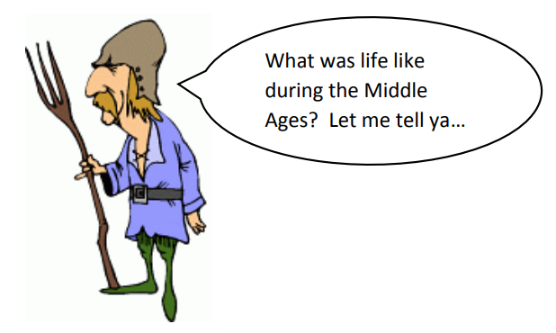

**Societal Role:**

**Examples:**

King Serf Knight

Peasant Noble (man/woman)

Merchant Clergy (bishop, priest)

Tradesperson Monk/Nun

**Chosen Societal role: ________________________________________________**

1. **______________________________________________________________________________________________________________________________________________________________**
2. **______________________________________________________________________________________________________________________________________________________________**
3. **Note taking sheet**

**Focus Question 1**

|  |
| --- |
| *What is the feudal system and what roles were part of the hierarchy of the feudal system?* |

**Key points from information sources and reference details**

|  |
| --- |
|  |

**Focus Question 2**

|  |
| --- |
| *What was the significance of the feudal system to Medieval Europe? What were some advantages and disadvantages of the feudal system?* |

|  |
| --- |
| **Key points from information sources and reference details** |

**Focus Question 3**

|  |
| --- |
|  |

**Key points from information sources and reference details**

|  |
| --- |
|  |

**Focus Question 4**

|  |
| --- |
|  |

**Key points from information sources and reference details**

|  |
| --- |
|  |

**Focus Question 5**

|  |
| --- |
|  |

**Key points from information sources and reference details**

|  |
| --- |
| Topic: |

**Bibliography – to be submitted on a separate piece of paper (6 marks)**

*Bibliography – a list of all the source you have referred to throughout your inquiry.*

You need to create a correctly formatted bibliography for any inquiry that you do. Record all the details of every source you access in your bibliography.

The rule is – **if you SIGHT it – CITE it!**

*Plagiarism – the practice of taking someone else’s work or ideas and passing them off as one’s own***.**

Narrogin Senior High School has a ZERO TOLERANCE POLICY regarding plagiarism.

**citethisforme.com** is a usual website for compiling references**.**

**Books**

**Example**: Arends, K. Humanities & Social Sciences 8, Pearson, 2017.

|  |  |  |  |  |
| --- | --- | --- | --- | --- |
| Author’s Surname | Author’s First name | (Year Published) | *Book Title (in Italics)* | Place of Publication: Book Publisher. |
| , | . | . | . | . |

**Websites**

**Example:** Cowley, R. Saladin, from the Readers Companion to Military History, 1996, <https://www.history.com/topics/saladin>, accessed 31/7/18

|  |  |  |  |  |  |
| --- | --- | --- | --- | --- | --- |
| Author’s Surname | Author’s First name | (Year Published) | *Website Title (In Italics)* | Website URL | Date you used the website. |
| , | . | . | . | . | Accessed: |

Once you have created your reference, all references are organised on a new page in ALPHABETICAL order by the author’s surname.

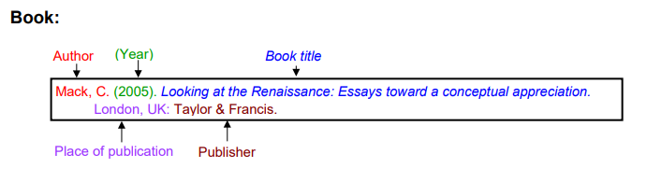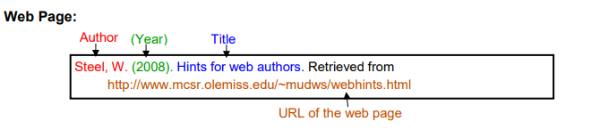

|  |  |  |  |  |  |
| --- | --- | --- | --- | --- | --- |
| **Author** | **Date last updated** | **Title of Webpage** | **Date accessed** | **HTTP** | |
|  |  |  |  |  | |
|  |  |  |  |  | |
|  |  |  |  |  | |
|  |  |  |  |  | |
|  |  |  |  |  | |
|  |  |  |  |  | |
| **Author** | **Date of Publication** | **Title of Book** | **Publisher** | | **Place of Publication** |
|  |  |  |  | |  |
|  |  |  |  | |  |
|  |  |  |  | |  |

**Reference recording sheet**

*Please note that in order to obtain full marks you must submit a formal bibliography, the table below is only for recording your references as you are researching.*

Teacher to tick when completed

Date:­­

Teacher Initial:

Teacher to tick when completed

Date:­­

Teacher Initial:

Teacher to tick when completed

Date:­­

Teacher Initial:

Teacher to tick when completed

Date:­­

Teacher Initial:

Teacher to tick when completed

Date:­­

Teacher Initial:

Teacher to tick when completed

Date:­­

Teacher Initial:

**Reflection**   **(6 marks)**

Please respond to the following four questions (*be specific)*:

I learnt …

|  |
| --- |
|  |
|  |
|  |
|  |

I was surprised …

|  |
| --- |
|  |
|  |
|  |
|  |

I wonder …

|  |
| --- |
|  |
|  |
|  |

**Year 8 – History –Medieval European Society (Inquiry Task) DETAILED MARKING GUIDE/RUBRIC - PART A: INQUIRY BOOKLET (4%)**

|  |  |  |  |  |  |  |  |
| --- | --- | --- | --- | --- | --- | --- | --- |
| **Task 🡫 &**  **Marks Allocation 🡪** | **1 - 2** | | | **3 - 4** | **5 - 6** | **7 - 8** | **Subtotal** |
| **KWL** | Presents a KWL which lacks detail and shows limited prior knowledge on the chosen topic. | | | Presents a detailed KWL which clearly outlines prior knowledge on the chosen topic. | Presents a very detailed and comprehensive KWL which clearly outlines prior knowledge on the chosen topic. |  |  |
| **Focus Questions** | Creates 1-2 basic focus questions that are loosely related to the topic. | | | Creates 3 detailed focus questions which are specific and related to the topic. |  |  |  |
| **Notetaking**  **Feudal System Description and roles** | Provides limited and/ or no notes for roles and description of feudal system. | | | Provides basic points notes that briefly addresses the focus question and provides limited information on the roles and description of the feudal system. | Provides generalised notes that address the role and description of the feudal system. Addresses research areas in some detail. Has constructed dot points from key information, though not always correctly. | Provides very detailed, comprehensive and accurate notes that addresses roles and describes the feudal system. Notes address research areas in detail and has constructed dot points from key information. Uses evidence from a range of sources. |  |
| **Notetaking**  **Significance and Advantages/Disadvantages of Feudal System** | Provides limited and/ or no notes for the significance and advantages/disadvantages of the feudal system. | | | Provides basic points notes briefly addresses the significance and advantages/disadvantages of the feudal system. Addresses research areas in limited detail. . | Provides generalised notes that address the significance and advantages/disadvantages of the feudal system. Addresses research areas in some detail. Has constructed dot points from key information, though not always correctly. | Provides very detailed, comprehensive and accurate notes that addresses the significance and advantages/disadvantages of the feudal system. Notes address research areas in detail and has constructed dot points from key information. Uses evidence from a range of sources. |  |
| **Notetaking**  **Focus Question 3** | Provides limited and/ or no notes that address the focus question. | | | Provides basic points notes briefly addresses the Focus Question. Addresses research areas in limited detail | Provides generalised notes that address the Focus Question. Addresses research areas in some detail. Has constructed dot points from key information, though not always correctly. | Provides very detailed, comprehensive and accurate notes that addresses the Focus Question. Notes address research areas in detail and has constructed dot points from key information. Uses evidence from a range of sources. |  |
| **Notetaking**  **Focus Question 4** | Provides limited and/ or no notes that address the focus question. | | | Provides basic points notes briefly addresses the Focus Question. Addresses research areas in limited detail | Provides generalised notes that address the Focus Question. Addresses research areas in some detail. Has constructed dot points from key information, though not always correctly. | Provides very detailed, comprehensive and accurate notes that addresses the Focus Question. Notes address research areas in detail and has constructed dot points from key information. Uses evidence from a range of sources. |  |
| **Notetaking**  **Focus Question 5** | Provides limited and/ or no notes that address the focus question. | | | Provides basic points notes briefly addresses the Focus Question. Addresses research areas in limited detail | Provides generalised notes that address the Focus Question. Addresses research areas in some detail. Has constructed dot points from key information, though not always correctly. | Provides very detailed, comprehensive and accurate notes that addresses the Focus Question. Notes address research areas in detail and has constructed dot points from key information. Uses evidence from a range of sources. |  |
| **Reflection** | Does not complete all sections of the self-reflection.  No self –reflection submitted(0) | | | Completes parts of the self-reflection using full sentences and uses some detailed examples. | Completes parts of the self-reflection and uses some detailed examples. |  |  |
| **Bibliography** | No bibliography submitted (0)  Bibliography includes a limited list of sources which may follow the referencing technique approved by the school, however, does not incorporate all requirements. | | | Bibliography includes a smaller range of sources which mostly follows the referencing technique approved by the school. | Collects information and images from a comprehensive number of sources and records a variety of key information, incorporating ethical protocols, which correctly follow the referencing technique approved by the school. |  |  |
|  |  |  |  | | | | **/62** |

Year 8 – History – Significant Individual from Medieval Europe (Inquiry Task) DETAILED MARKING GUIDE/RUBRIC - PART B: MUSEUM DISPLAY (3.5%)

|  |  |  |  |  |  |
| --- | --- | --- | --- | --- | --- |
| **Task 🡫 &**  **Marks Allocation 🡪** | **8 - 10** | **5 - 7** | **2 - 4** | **0 - 2** | **Subtotal** |
| **Information: relationships / rights and privileges.** | Provides a very detailed description of the relationships and rights/privileges of chosen societal role. | Provides a detailed description of the relationships and rights/privileges of chosen societal role. | Has briefly outlined the relationships and rights/privileges of chosen societal role. | Has provided little or no description of the relationships and rights/privileges of chosen societal role. |  |
| **Information: Significance of societal role** | Provides a very detailed description on the significance of chosen societal role. | Provides a detailed description on the significance of chosen societal role. | Has briefly outlined the significance of chosen societal role. | Has provided little or no description of the significance of chosen societal role. |  |
| **Information: Daily Life** | Provides a very detailed description on the daily life of the chosen societal role. | Provides a detailed description on the daily life of the chosen societal role. | Has briefly outlined the daily life of the chosen societal role. | Has provided little or no description of the daily life of the chosen societal role. |  |
| **Information: Interesting facts on role or object.** | Provides a very detailed description on other interesting facts on the chosen societal role or object. | Provides a detailed description on other interesting facts on the chosen societal role or object. | Has briefly other interesting facts on the chosen societal role or object. | Has provided little or no description of other interesting facts on the chosen societal role or object. |  |
|  | **5 - 6** | **3 - 4** | **1 - 2** | **0** |  |
| **Use of examples/supporting evidence** | Has selected supporting evidence/examples that effectively reinforce the information of the chosen societal role. | Has selected supporting evidence/examples that mostly reinforces the information of the chosen societal role. | Has selected a narrow range of supporting evidence/examples that do not necessarily reinforce the information of the chosen societal role. | Has not provided any supporting evidence/ examples. |  |
|  | **6 - 8** | | **3 -5** | **0 - 2** |  |
| **Presentation-Visual** | Presentation is visually engaging. Displays a high level of detail and presents information about the feudalism and societal roles to a high standard. It is clear that a lot of time and thought is put into the presentation. | | Presentation is engaging. Displays a satisfactory level of detail and overall presents information about feudalism and societal roles to a satisfactory standard. Some time and thought is put into the presentation. | Presentation is somewhat engaging. Displays limited amount of detail and presents little information about feudalism and societal roles. Little time or thought is put into the presentation. |  |
| **Task 3 - TOTAL** | **/54** |